OOAD K.BHAVYA SREE (192311388)
Question 7: Railway Reservation System – Package Diagram
Scenario:
A railway reservation portal consists of multiple modules including passenger management, train scheduling, ticket booking, payment processing, cancellation, and reporting. Each module has independent responsibilities but communicates with others when required. Ticket booking depends on seat availability. Payment processing communicates with external banking systems. Reporting collects information from all modules. Administrators manage train schedules and fares. The software team wants to organize system components into logical packages for better maintainability. Proper dependency management is essential.
Lab Activity: Design a Package Diagram for the Railway Reservation System.
1.USE CASE DIAGRAM
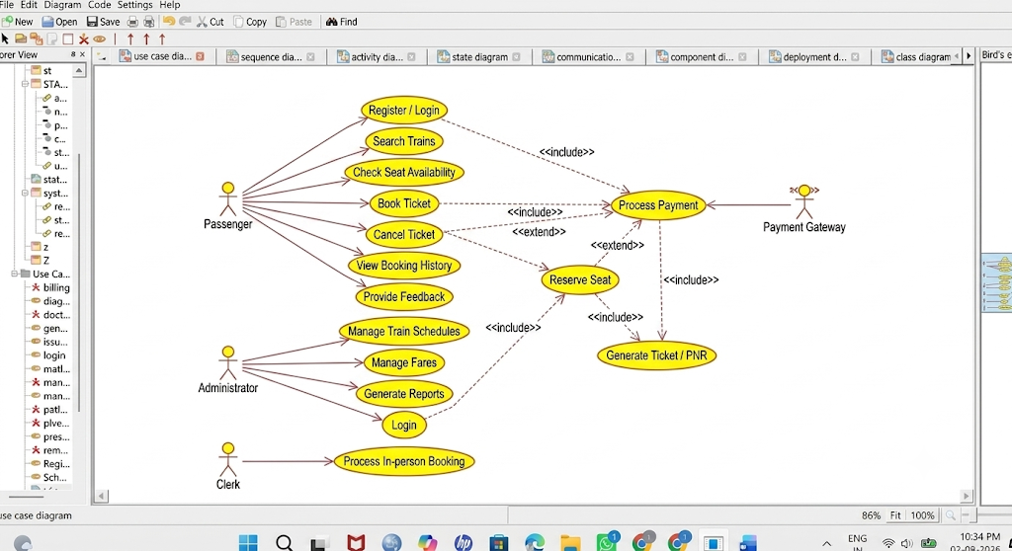
2. CLASS DIAGRAM:
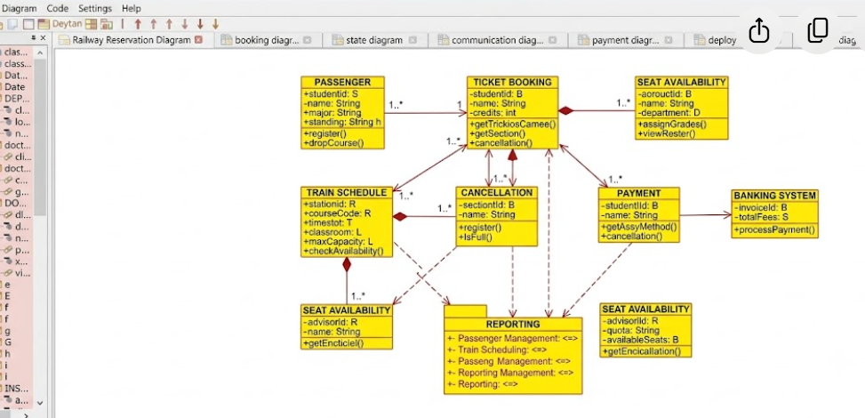
ACTIVITY DIAGRAM:

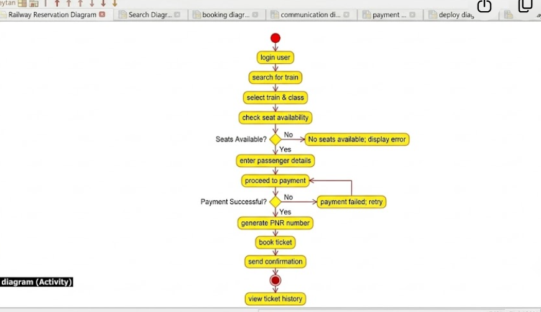

DEPLOYMENT DIAGRAM:
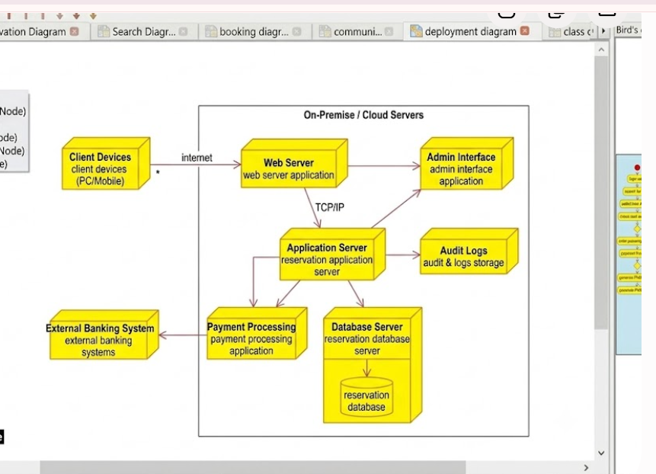
SEQUENCE DIAGRAM:
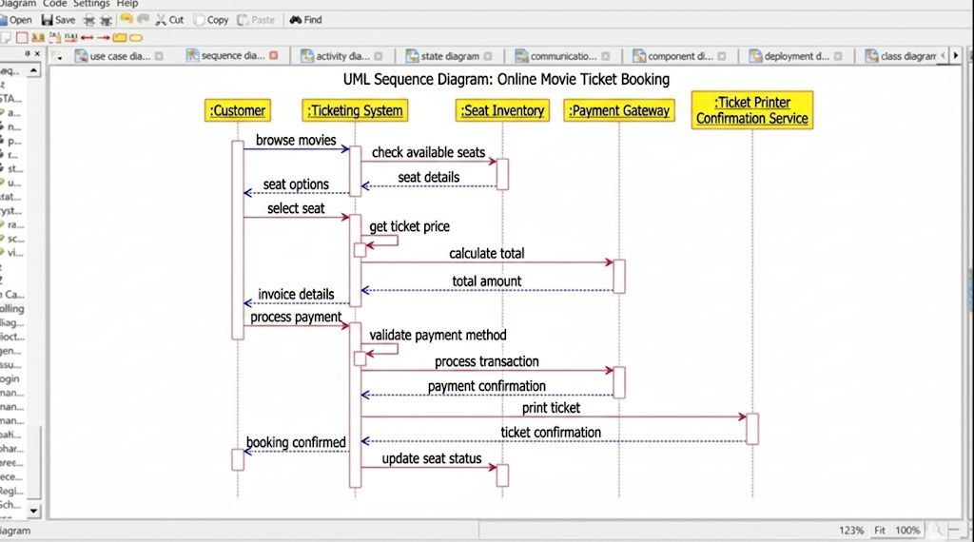

STATE MACHINE DIAGRAM:
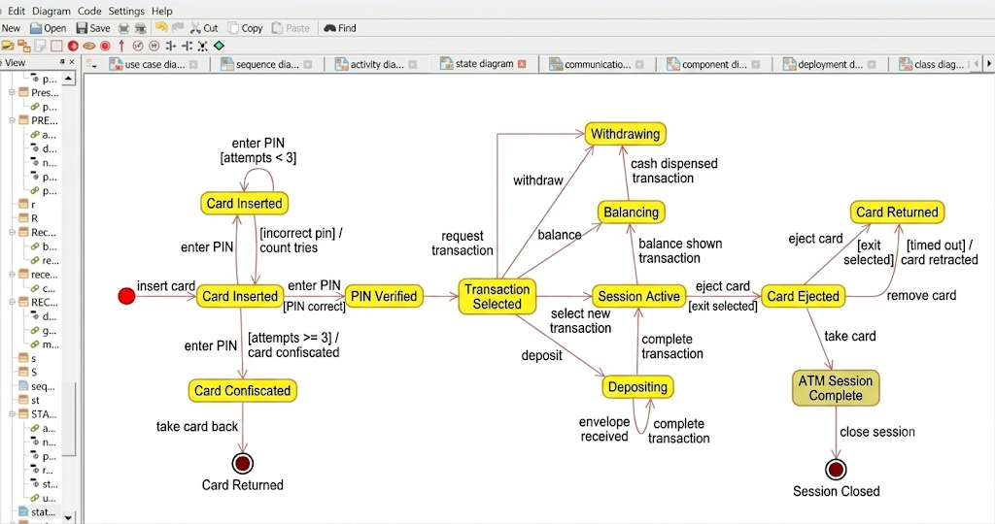

COMPONENT DIAGRAM:
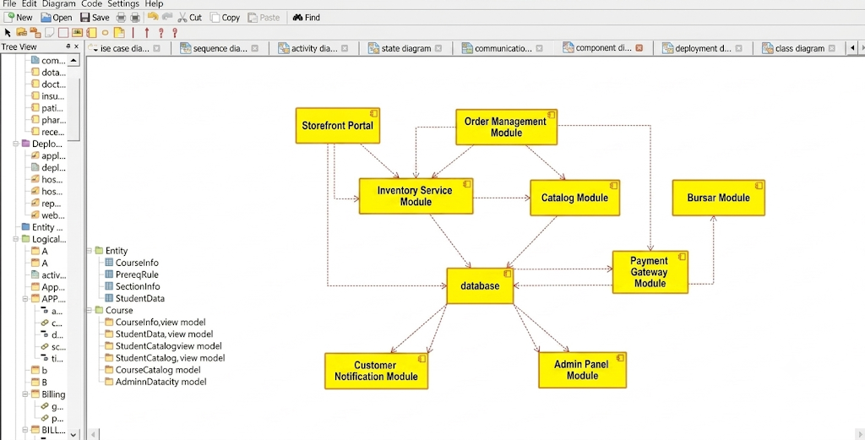
COMMUNICATION DIAGRAM:
